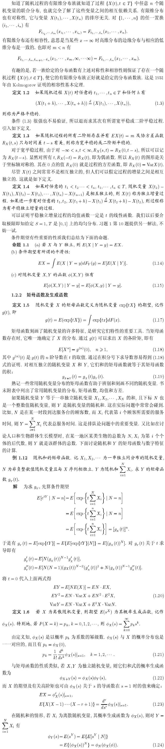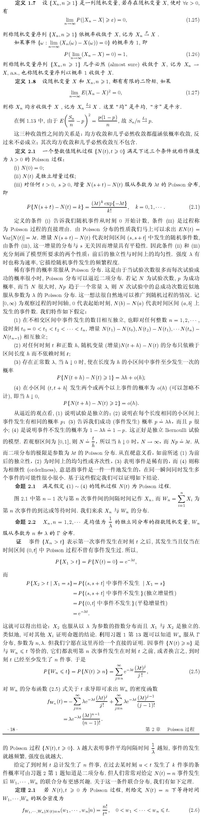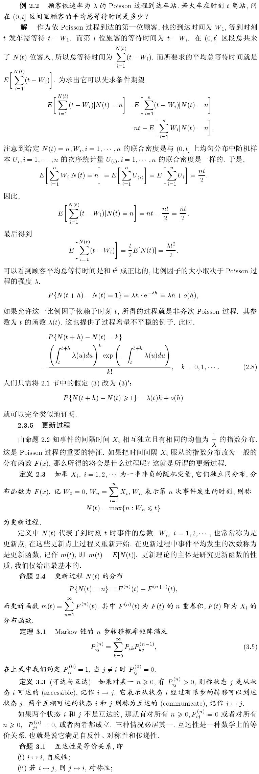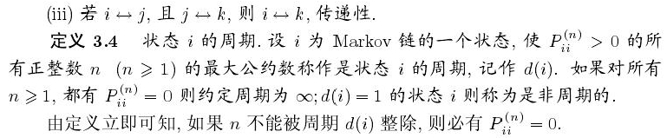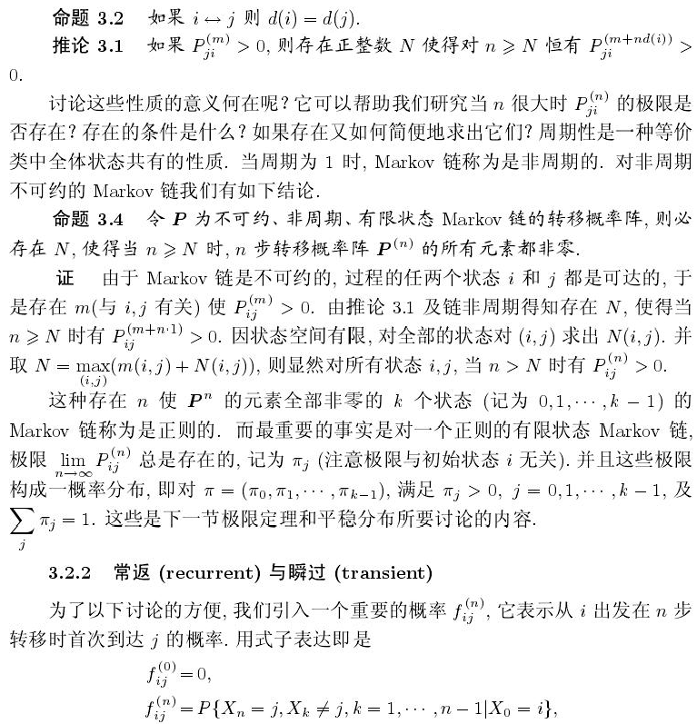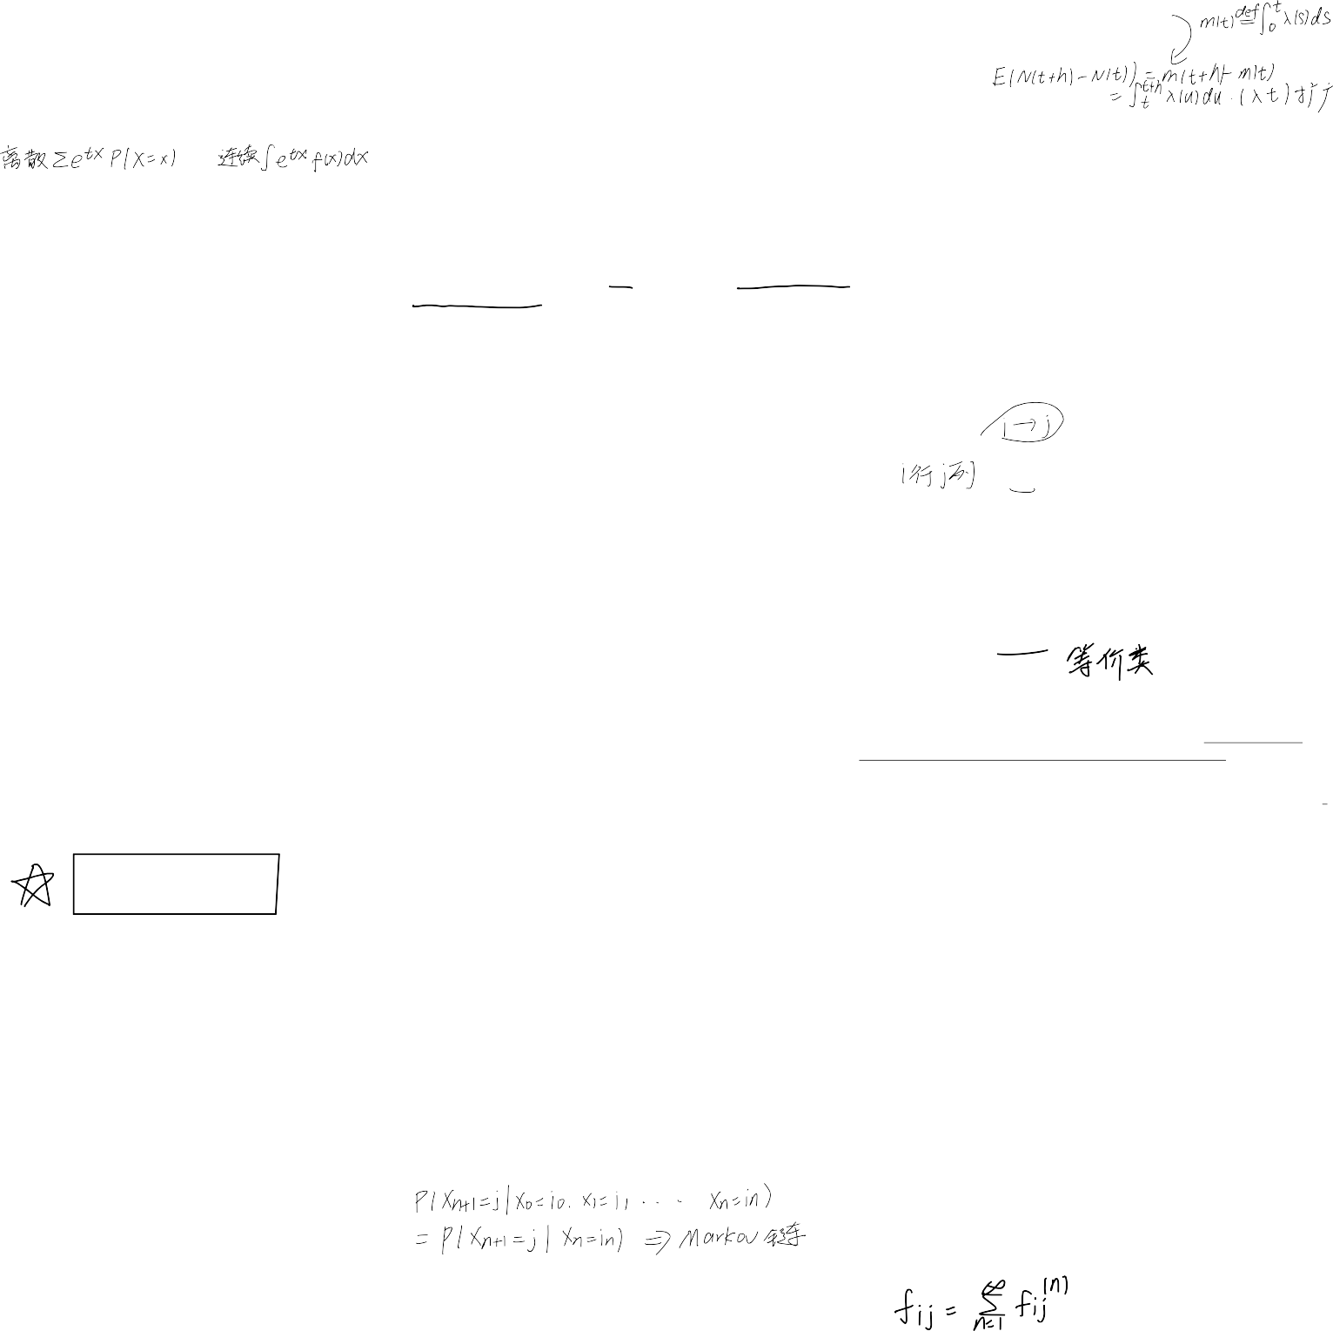

分布|P(X = x)/𝑓(𝑥) |矩母|EX|Var(X)

𝐵(𝑛, 𝑝)|𝐶x𝑝x(1 — 𝑝)n–x|(𝑝𝑒t + (1 — 𝑝))n|𝑛𝑝|𝑛𝑝(1 — 𝑝)

n

𝑝𝑜𝑖𝑠𝑠𝑜𝑛| e—ഊλx |𝑒𝑥𝑝{𝜆(𝑒t — 1)}|𝜆| 𝜆

x!

几何|𝑝(1 — 𝑝)x–1| pet

| 1 | 1–p

1–(1–p)et p p2

|Cr–1 r( )x–r|

pet r r r(1–p)

负二项 x–1 𝑝 1 — 𝑝

(1–(1–p)et) | p | p2

𝑈(𝑎, 𝑏)| 1 | eta–etb | a+b | (b–a)2

b–a t(a–b) 2 12

指数|𝜆𝑒–λx| λ | 1 | 1

2

λ–t λ λ

Г(𝑛, 𝜆) |λe—ഊx(λx)n—1|(

(n–1)!

λ n n n

) | | 2

λ–t

1 (x—μ)2

λ λ

σ2t2

𝑁(𝜇, 𝜎2)| 𝑒– 2σ2 |exp {𝜇𝑡 +

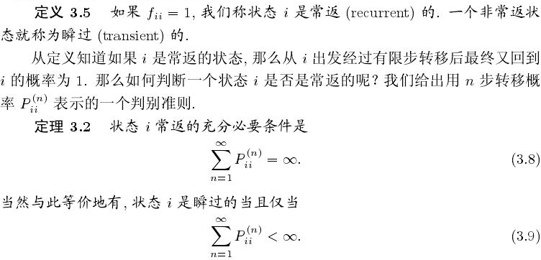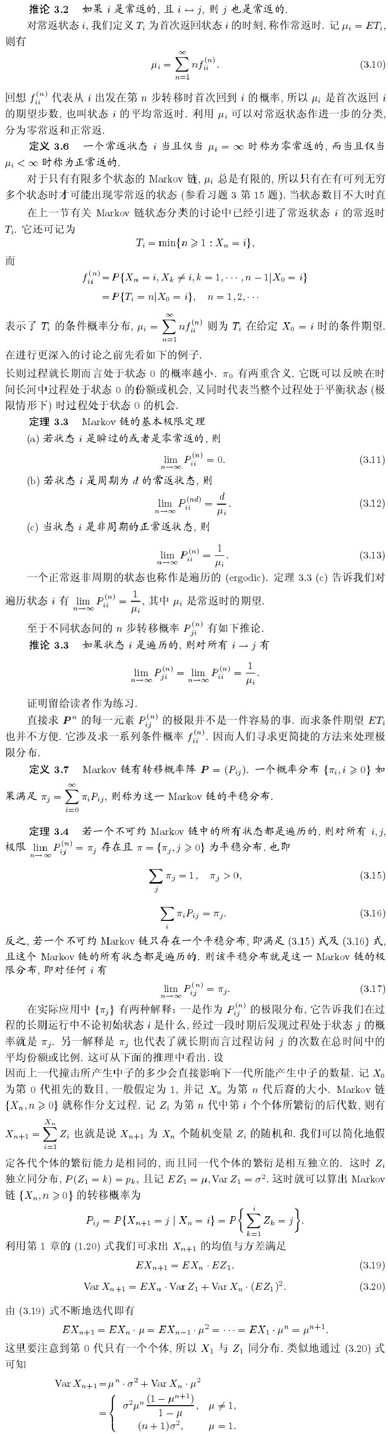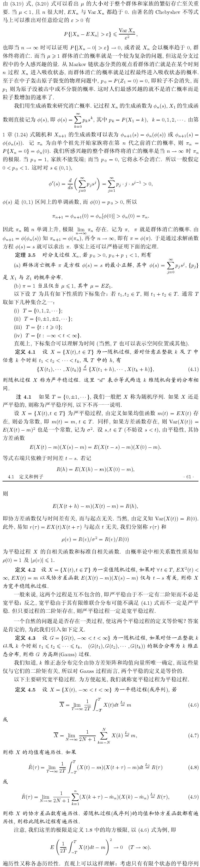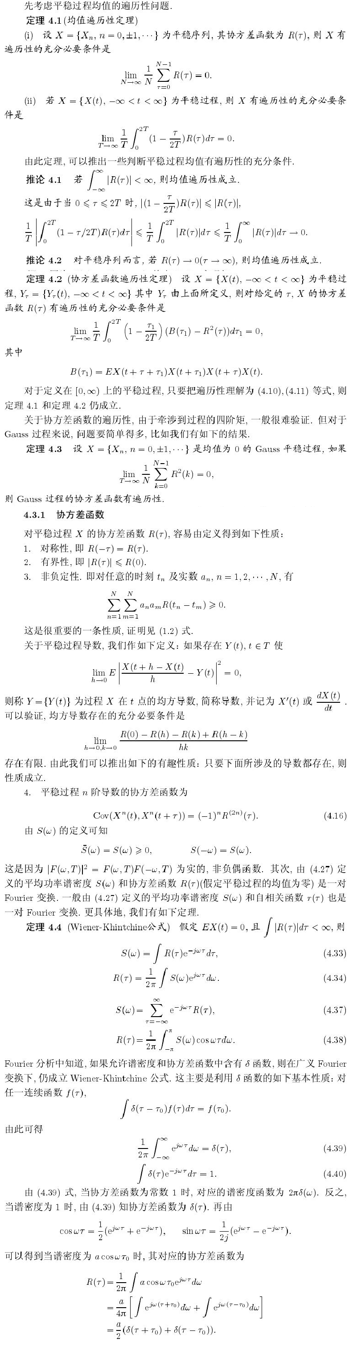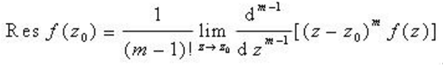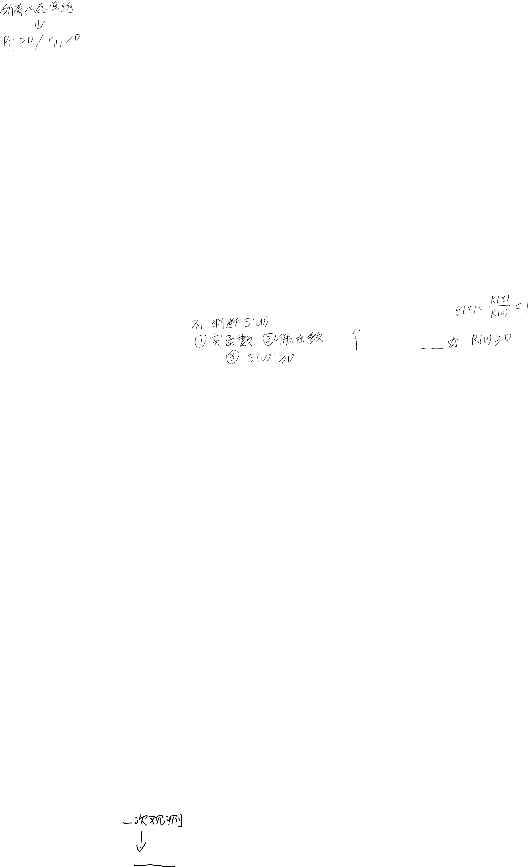

√2πσ

}|𝜇|𝜎2 made

